**Table of Contents**

**1. Introduction ..............................................................................................................................2**

1.1 Purpose .......................................................................................................................................... 2

1.3 Flow Chart……………………………………………………………………………………………………………………………….…2

1.2 Scope ............................................................................................................................................. 3

1.4 Sprint planning Stories ………………………………………………………………………………………………………………4

1.5 Functions.........................................................................................................................................5

**1 Introduction**

Required to complete the features of the application by planning the development in terms of sprints and then push the source code to the GitHub repository. As this is a prototyped application, the user interaction will be via a webBrowser.

**1.1 Purpose**

FlyAway(An airline Booking Portal) wants to launch a portal for online flights reservation. Company asked to develop a portal with name as FlyAway. The prototype of the application will be then presented to the relevant stakeholders for the budget approval. Manager has set up a meeting where to present the prototype application developed in three weeks.

**FlyAway (An Airline Booking Portal).**

**1.2 Flow Chart**

Reservation Done

Home Page

Payment Confirmation

Register Details

Select Flight

Select Flight

Search Flights

User Login

Search Travel History

Change Password

Admin Login

Start

**1.3 Scope**

Required to develop a online portal in two weeks and present the basic functionality.

* Generic features and operations:
  + Admin Login
* Admin can change password
* Admin can login and search travel history
  + User Login
    - User can login and search flights by specifying travel date, source and destination
    - User will select the searched flights
    - On flight selection user will register details
    - User details will register his details
    - Once registration done user will proceed for payment
    - After successful registration user will navigate to home page again

**1.4 Sprints**

|  |
| --- |
| Number of Sprints: 2 |
| Sprint 1:   * Meeting * Design the Application * Developing the application   Sprint 2:   * Meeting * Finalizing the Application * Present the Application |

**User Stories:**

|  |
| --- |
| **Stories**   * **As user, I want to design the welcome screen to be more appealing to the customer** * **As a developer, I want to design the user interface so users can experience an easy, intuitive, and less effort in using the application but they receive an excellent outcome** * **Navigation control or options make the user navigate the features of the application easily.** |

**Number of Tasks:**

|  |
| --- |
| **Tasks:**   * **Designing the welcome page** * **Designing the features of the application** * **Designing the navigation control** * **Code** * **Review the code** * **Present the finish project** |

**1.5 Functions**

**Welcome Screen**

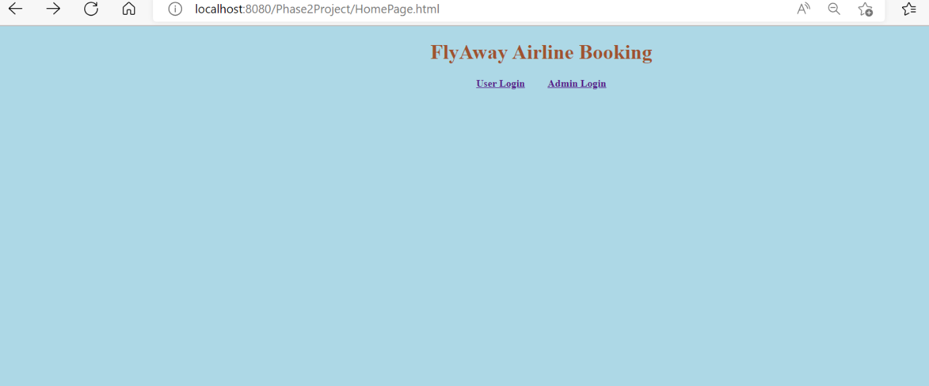

**Step 1:**

Admin user will login and can-do search travel history or change password.

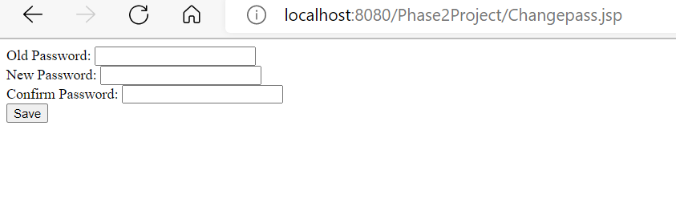

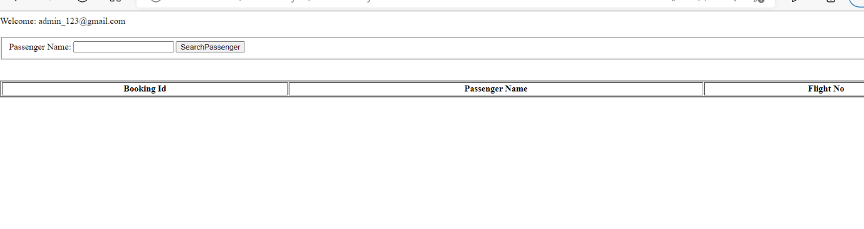

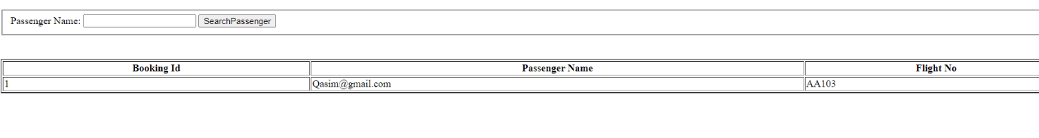

**step 2:**

Normal user can login and search flight then select flight and reserve after payment.

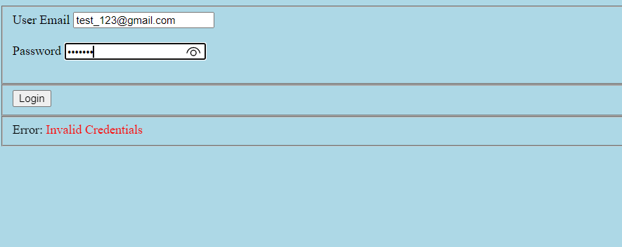

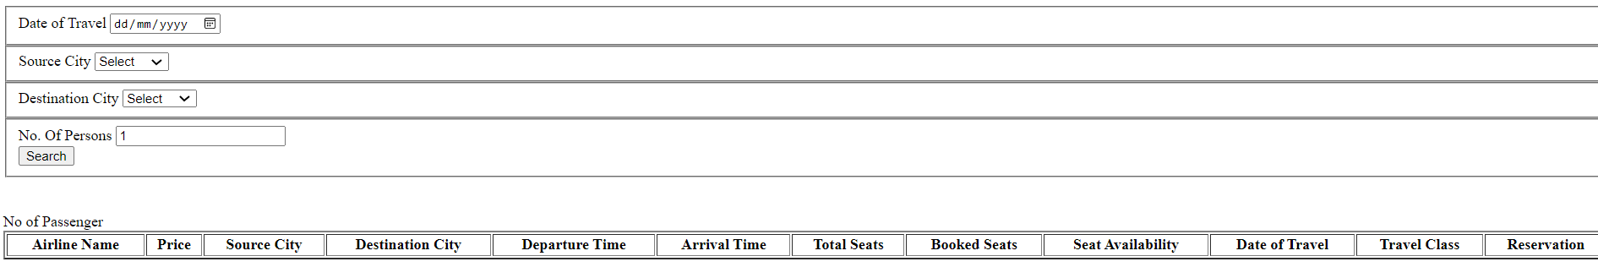

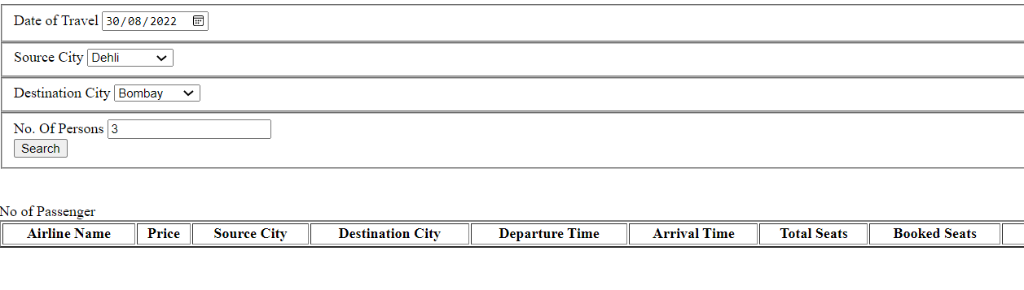

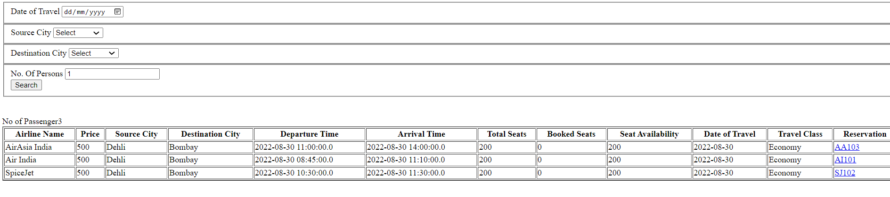

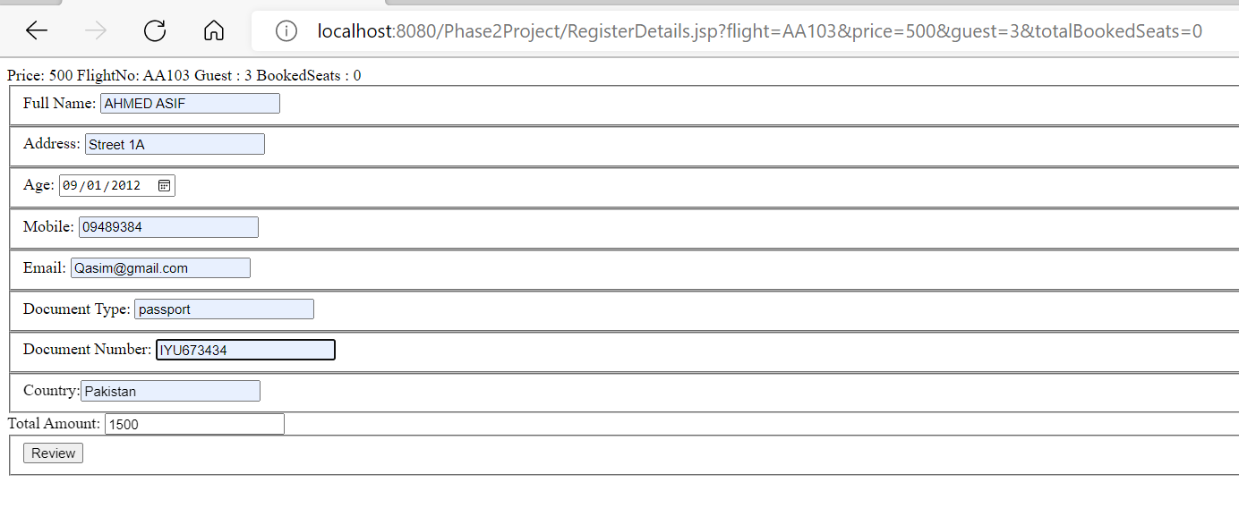

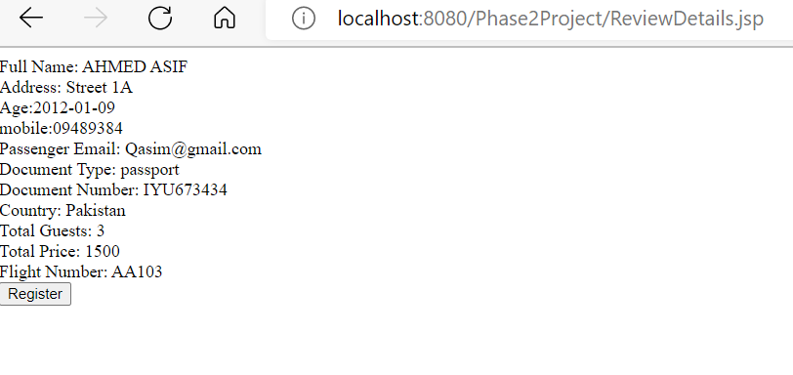

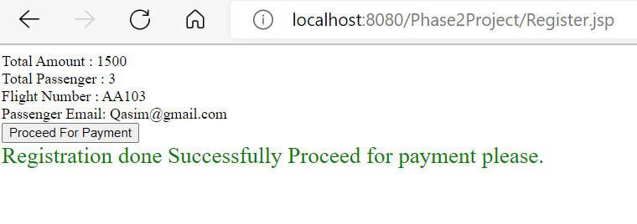

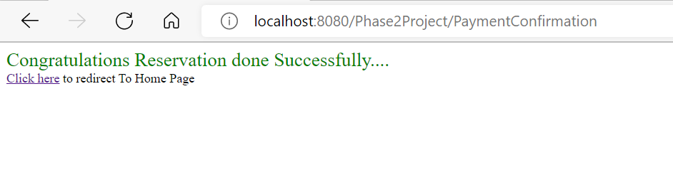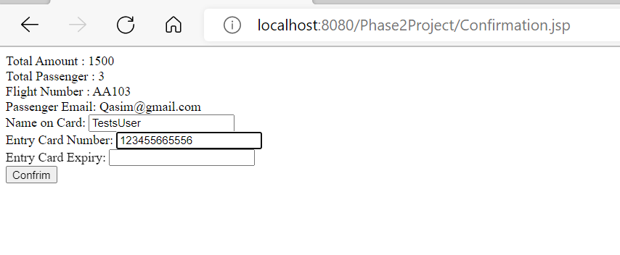

**Git Hublink**

https://github.com/HasanRaza9/Phase2/tree/main/Phase2Project